In prior iterations, you designed your database schema with both conceptual and logical ERDs, and began implementing the design using SQL. Great work! Now you have a chance to further implement your database with SQL by implementing Aspects 2 and 3.

This work is summarized in the steps below.

1. Make any enhancements and corrections to your business rules and provide the updated list below.

2. Make any enhancements and corrections to your conceptual ERD and provide the updated ERD below.

3. Make any enhancements and corrections to your logical ERD and provide the updated ERD below.

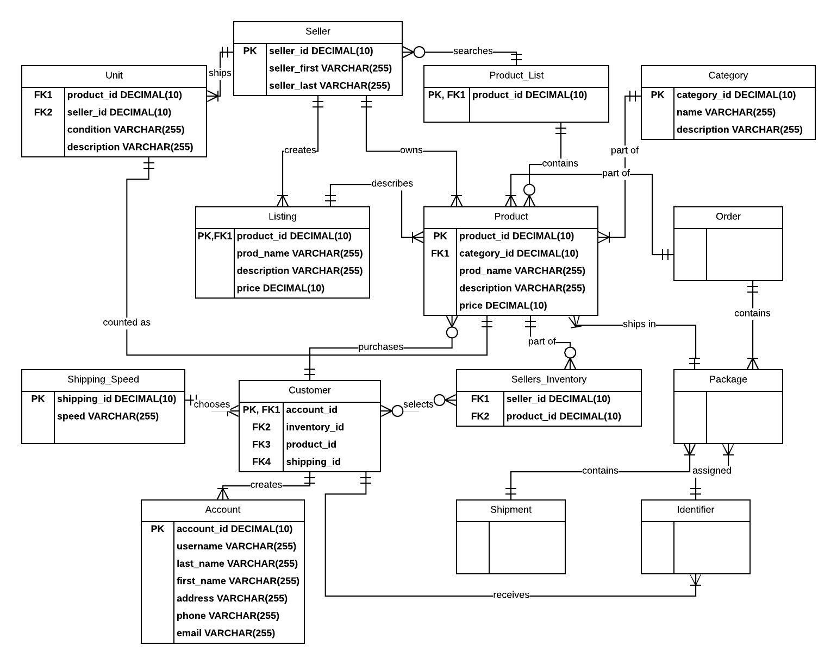

**Completing the remaining iteration for Aspect 1 from last week (I did not have time to finish everything last week due to work obligations).**

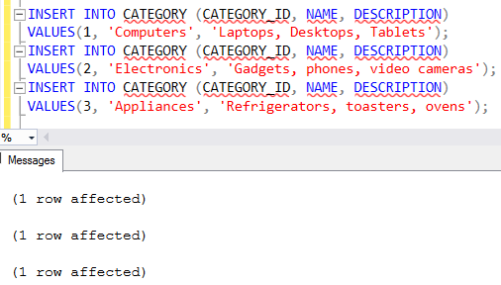

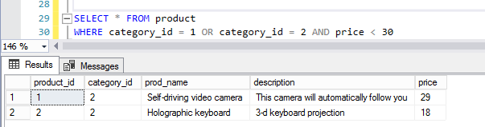

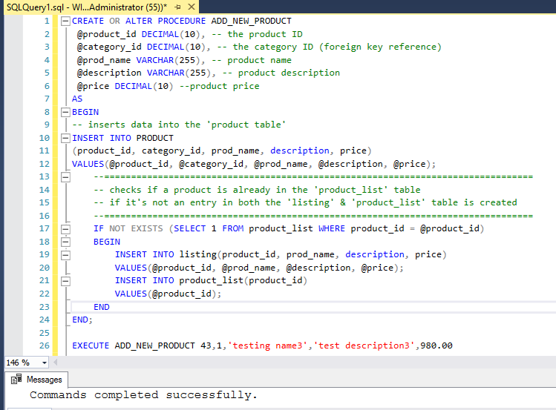

4. Create and execute the SQL for Aspect 2. Provide screenshots.

1. Tables and constraints.

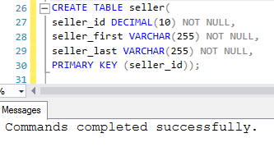

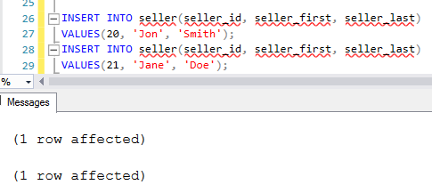

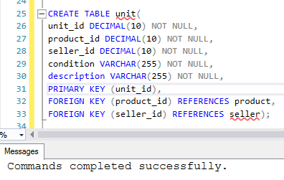

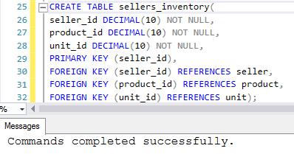

1. Reusable stored procedure.

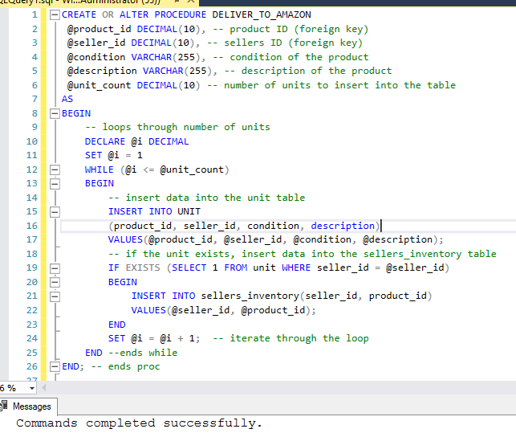

1. Use of the stored procedure.

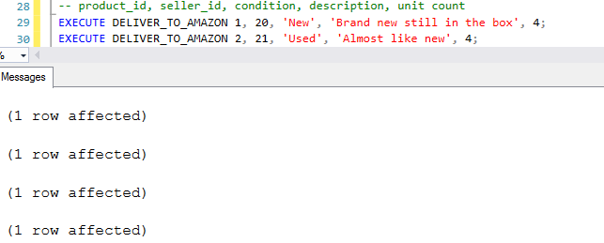

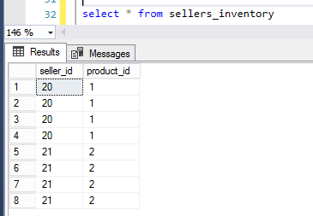

1. SQL query.

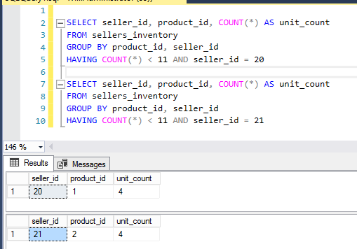

5. Create and execute the SQL for Aspect 3. Provide screenshots.

1. Tables and constraints.

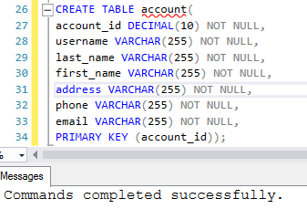

1. Reusable stored procedure.

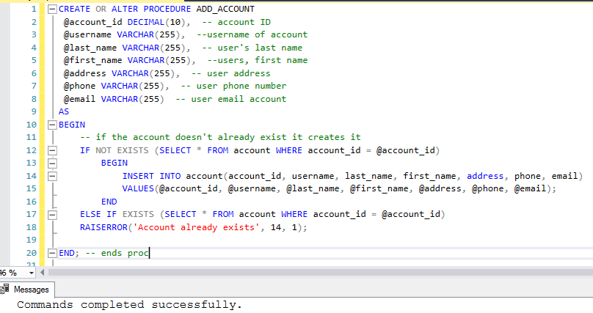

1. Use of the stored procedure.

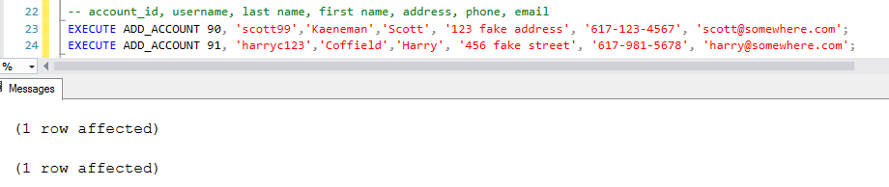

1. SQL query.

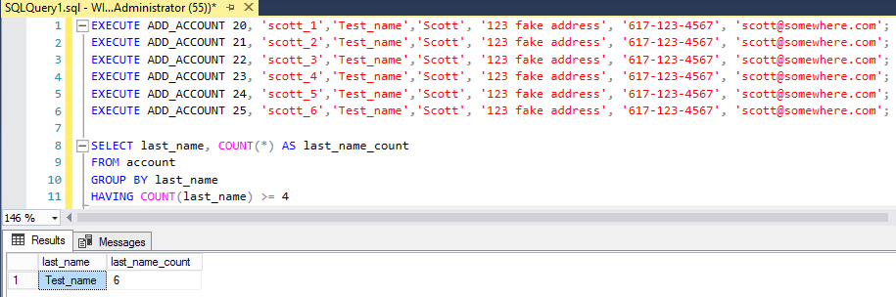

This iteration is not your final term project submission. You have the opportunity to modify all sections of your term project before the final submission at the end of the course.

